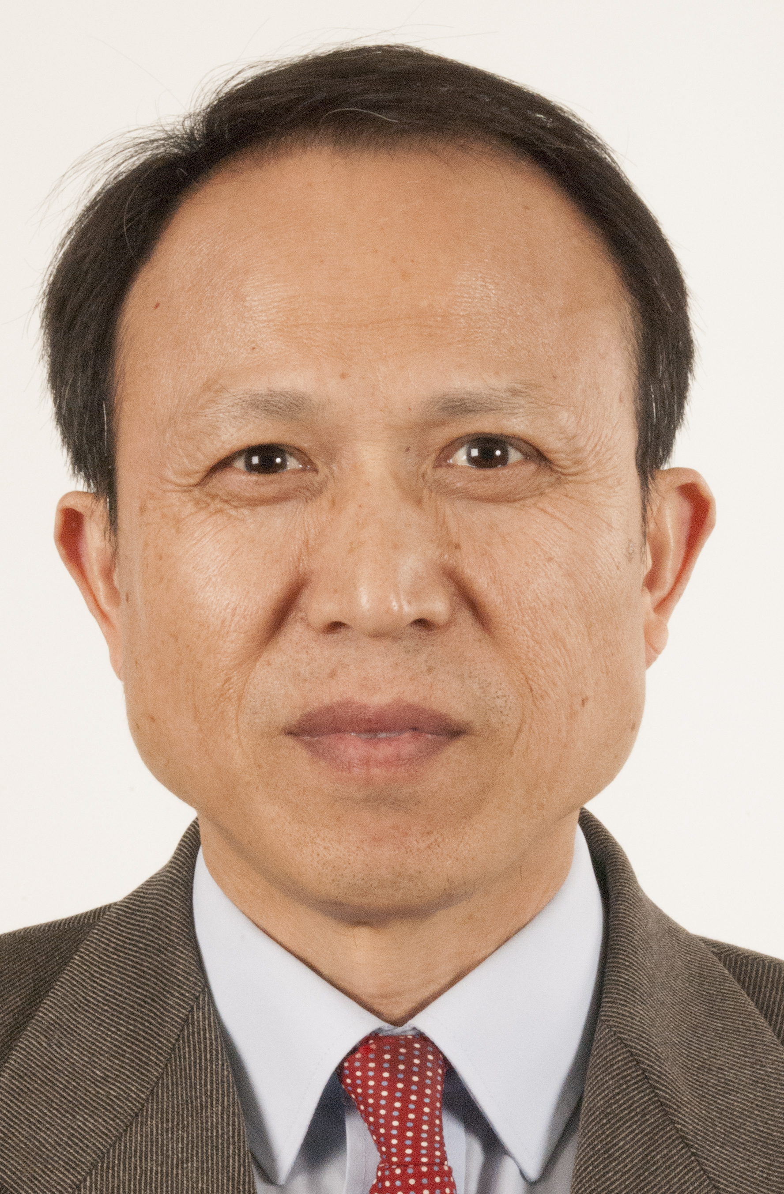
Jiangzhou Wang is currently a Professor of Telecommunications and the Head of the School of Engineering and Digital Arts, University of Kent, United Kingdom. He has authored over 200 papers in international journals and conferences in the areas of wireless mobile communications and three books.

Professor Wang was the Technical Program Chair of the 2013 IEEE WCNC in Shanghai and the Executive Chair of the 2015 IEEE ICC in London. He serves/served as an Editor for a number of international journals. For example, he was an Editor for IEEE Transactions on Communications from 1998 to 2013 and was a Guest Editor for IEEE Journal on Selected Areas in Communications. He is currently an Editor for Science China Information Science. He received the Best Paper Award from the 2012 IEEE GLOBECOM. Professor Wang was an IEEE Distinguished Lecturer from 2013 to 2014. He is an IET Fellow.

His research interests include wireless multiple access and radio resource allocation techniques, massive MIMO and small-cell technologies, device to device communications in cellular networks, and distributed antenna systems.

