Seminar Announcement

9:00 a.m. ~ 12:00 a.m., January 19, 2017, Room: 107, GREAT

Title: Performance Increasing for 5G LTE-Unlicensed Users
by MPTCP Proxy-based LTE and WiFi Aggregation
Yuanjie (Won Gul) Li and Prof. Minho Jo

Abstract
The phenomenal growth of mobile data demand over wireless networks has brought increasing scarcity in available radio spectrum. In order to solve the problem of dramatically increasing mobile network capacity demand, utilizing the unlicensed spectrum, especially 5 GHz unlicensed spectrum has been considered recently as a promising solution for 5G Long Term Evolution (LTE). One of the approaches led by the 3rd Generation Partnership Project (3GPP) is Licensed Assisted Access (LAA), which has been specified in Rel-13. LAA allows LTE operate in unlicensed bands such as 5 GHz WiFi with Listen Before Talk (LBT) channel access mechanism. On the other hand, in addition to LAA, Internet Engineering Task Force (IETF) has introduced another solution, “Multipath TCP (MPTCP) Proxy-based LTE-WiFi aggregation (LWA).” MPTCP Proxy-based LWA can separate LTE data and WiFi data, respectively and then transmit them through both LTE and WiFi networks concurrently. In this research, we evaluate the performance of LAA and MPTCP Proxy-based LWA, respectively in the same network topology with ns-3 network simulation tool. Furthermore, we propose a comprehensive solution by combining both LAA and MPTCP techniques in order to enhance overall performance. We evaluate the energy consumption of 5G mobile devices under LTE-Unlicensed networks.

Biography
Minho Jo (SM’07) received the B.A. degree from the Department of Industrial Engineering, Chosun University, South Korea, in 1984, and the Ph.D. degree in computer networks from the Department of Industrial and Systems Engineering, Lehigh University, USA, in 1994. He is currently a Professor with the Department of Computer and Information Science, Korea University, Sejong City, South Korea. He is one of the founders of the Samsung Electronics LCD Division. Areas of his current interests include LTE-unlicensed, Internet of Things, cognitive networks, HetNets in 5G, green (energy efficient) wireless communications, mobile cloud computing, 5G wireless communications, optimization and probability in networks, network security, software defined networks, and massive MIMO. He received the Headong Outstanding Scholar Prize with price money of U.S. $20 000 in 2011. He is the Founder and Editor-in-Chief of the KSII Transactions on Internet and Information Systems [SCI (ISI) and SCOPUS indexed, respectively]. He is an Editor of the IEEE Wireless Communications, and an Associate Editor of the IEEE INTERNET OF THINGS JOURNAL, Security and Communication Networks, Ad-Hoc & Sensor Wireless Networks, and Wireless Communications and Mobile Computing. He is the Vice President of the Institute of Electronics and Information Engineers and was the Vice President of the Korea Information Processing Society.
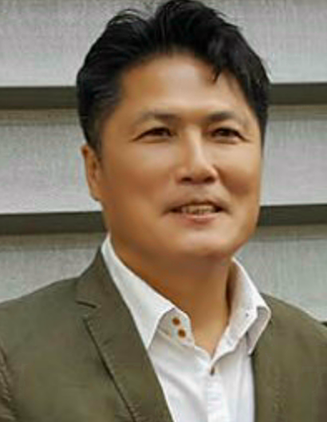
LI YUANJIE (wongul929@korea.ac.kr) is now a combined M.S and Ph.D. degree program student in the Department of Computer and Information Science, Korea University, Sejong Metropolitan City, S. Korea. He received his dual B.A. degrees in Department of Computer Science and Department of Electronics Engineering, Handong University, S. Korea in 2014. He worked as a software engineer in the San Engineering Co., Bundang, S. Korea in 2015. His research interests include Internet of Things (IoT), mobile cloud computing, mobile edge computing, LTE in unlicensed spectrum and heterogeneous network in 5G.
