悉尼科技大学毛国强教授学术报告

报告题目：Key Technologies for Next-generation Wireless Systems
报告人：毛国强教授
报告时间： 2014年4月14日上午10: 00-11: 00
报告地点：南一楼中302（电信系会议室）

Title of the talk: Key Technologies for Next-generation Wireless Systems

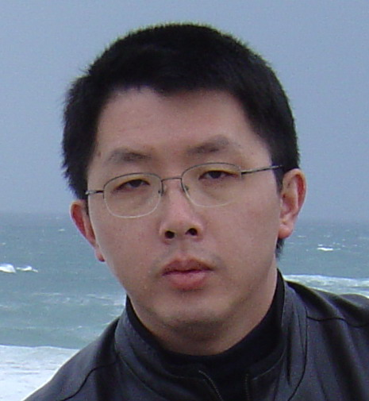
Bio:
Guoqiang Mao received PhD in telecommunications engineering in 2002 from Edith Cowan University, Australia. Between 2002 and 2013, he was with the School of Electrical and Information Engineering, the University of Sydney, as a Lecturer, a Senior Lecturer and an Associate Professor. He joined the University of Technology, Sydney as a Professor of Wireless Networking and Director of University Center for Real-time Information Networks in February 2014. He has published more than 100 papers in top international conferences and journals, which have been cited more than 2000 times (Google Scholar). His research interest includes intelligent transport systems, applied graph theory and its applications in networking, wireless multihop networks, wireless localization techniques and network performance analysis. He is a Senior Member of IEEE, an Editor of IEEE Transactions on Vehicular Technology and a co-chair of IEEE Intelligent Transport Systems Society Technical Committee on Communication Networks. He has served as a chair and a technical committee member in a number of international conferences.

Abstract:
The fourth generation of mobile communication system has just started to be rolled out across the globe. The extra data rate offered by 4G will soon be consumed and exceeded by emerging data rate demanding services like ultra high definition video and immersive multimedia. Naturally next generation wireless system, commonly known as 5G, has been put onto the table. In this talk, we will sift through all the myths surrounding 5G and discuss potential key technologies and development trends for 5G.

